**Mental health and well-being surveillance, assessment and tracking solution among students**

**PROJECT SYNOPSIS**

OF MAJOR PROJECT

**BACHELOR OF TECHNOLOGY**

## CSE

SUBMITTED BY

Ashutosh Verma

Ananya Verma

Arpita

Project Guide

Prof. / Dr. Preeti Garg



## **KIET Group of Institutions, Delhi-NCR,**

## **Ghaziabad (UP)**

## **Department of Computer Science and Engineering**

October 2023

**Table of contents**

|  |  |
| --- | --- |
| **Content** | **Page no.** |
| Introduction | 1 |
| Rationale | 2 |
| Objective | 2 |
| Literature Review | 3 |
| Feasibility Study | 5 |
| Methodology | 6 |
| Facilities required for Work | 7 |
| Expected Outcomes | 7 |
| References | 7 |

**INTRODUCTION**

Saathi is an Android application that serves as a platform for students and teachers helping them tackle various mental health issues such as anxiety, panic, depression.

The most attractive feature of Saathi is that it generates AI voices of your loved ones that can be used to comfort the user when needed.

Field of project:

* Mental health tracker and chatbot-based assistant
* User can address his/her grievances to Apna Saathi chatbot.
* Recommended exercises and positive affirmations.
* Time management system
* User will enter pending tasks, their priority and approximate time they might take and system will automatically assign time to tasks.

Technology used:

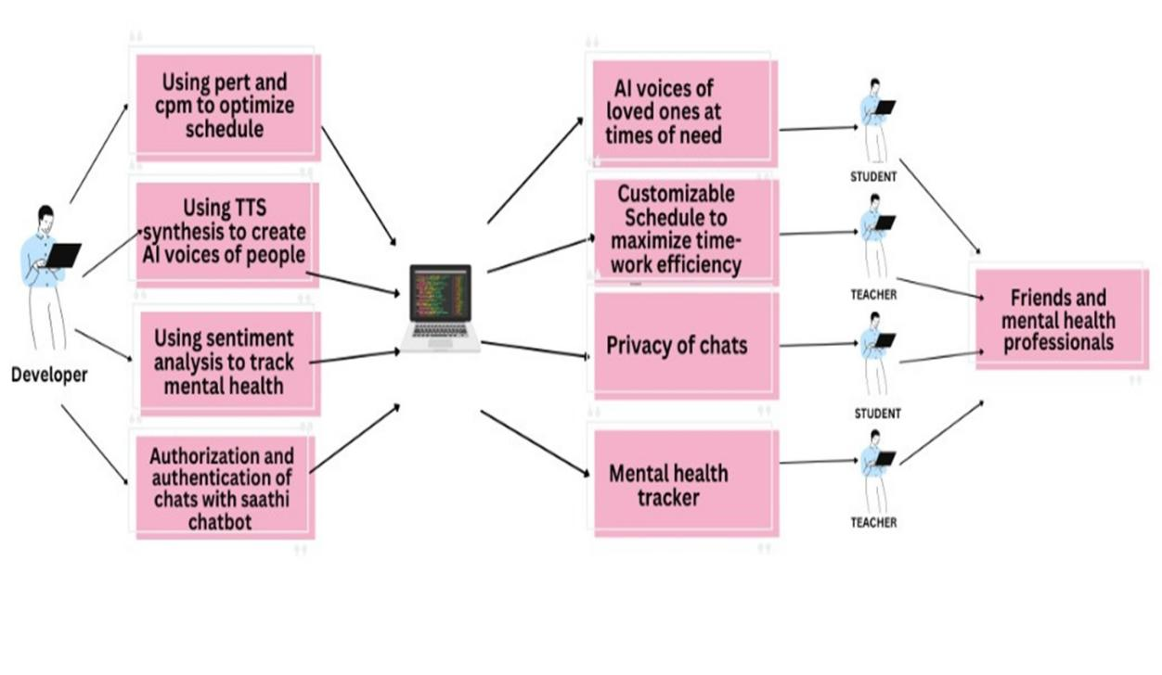

**RATIONALE**

Saathi, an Android application, emerges in response to the growing imperative to address mental health challenges prevalent in academic settings. By amalgamating a mental health tracker and a chatbot-based assistant, Saathi aims to facilitate seamless access to support and resources for students and teachers. Through its AI technology, it generates comforting voices of loved ones, fostering emotional support during critical moments.

Furthermore, it promotes holistic well-being by providing recommended exercises, affirmations, and a user-friendly time management system.

The underlying rationale for Saathi's development lies in fostering a supportive ecosystem that nurtures mental wellness and resilience within the academic community, ultimately empowering individuals to prioritize their mental health and overall growth.

**OBJECTIVE**

* Develop a sophisticated system for monitoring and evaluating the mental health of children.
* Integrate innovative features such as AI voices of loved ones, a mental health tracker, and a chatbot with sentiment analysis to provide comprehensive support.
* Offer timely interventions and resources to promote positive mental health outcomes among children.

**LITERATURE REVIEW**

**Behavioral Activation-based AI chatbot [1]**

The personalized conversation engine, built on the Rasa chatbot framework, employs BA-oriented Natural Language Processing (NLP) components, comprising a feature extractor, intent and entity extraction, and response selector. The feature extractor processes user text, extracting various sparse and dense features, including lexical and syntactic information and count vector representations using BERT Language model embeddings.

Intent classification and entity extraction are handled by the DIET classifier and SpaCy library, with emotion and sentiment analysis carried out by DeepMoji and the Flair framework, respectively. The response selector, using a neural network model, matches user input, intent, and entities to predefined responses via k-Nearest-Neighbour (kNN). An emergency detector overrides responses in critical situations.

In terms of emotional support, the AI chatbot focuses on behavioral activation (BA) principles, promoting activity scheduling to improve mental and emotional well-being. Users schedule and receive reminders for activities, providing feedback on mood changes. This data informs activity recommendations to enhance the user's mood.

Remote health monitoring, based on Ecological Momentary Assessment (EMA), captures real-time emotions and sentiments during user interactions. Mood scores and health questionnaires are used to assess and track emotional states, with PHQ2 serving as an initial depression screening. The seven-day rolling mood score provides short-term mood metrics, and data is collected for long-term behavioral insights.

$$7−day average mood score \frac{Sum of daily mood scores for the last 7 days}{Number of mood scores for the last 7 days}$$

**Neural Voice Cloning with a Few Samples [2]**

Two approaches for neural voice cloning were studied: Speaker Adaptation and Speaker Encoding. It was demonstrated that both approaches could achieve good cloning quality even with only a few cloning audios. For naturalness, it was shown that both speaker adaptation and speaker encoding achieved an MOS similar to the baseline multi-speaker generative model.

In this study, a multi-speaker generative model (parameterized by W and esi) is used for voice cloning. The model aims to minimize the difference between generated and ground-truth audios, optimizing W and esi through a loss function. Speaker embeddings effectively capture speaker characteristics.

Voice cloning involves speaker adaptation, which fine-tunes the model for unseen speakers using a few audio-text pairs, and speaker encoding, which directly estimates the speaker embedding from audio samples. The speaker encoder (parameterized by Θ) is trained to predict embeddings from cloning audios. Joint training from scratch can be challenging, and discriminative loss functions may be introduced to improve speaker differences. The speaker encoder architecture involves spectral processing, temporal processing with convolutional layers, and cloning sample attention using self-attention.

Overall, the study explores techniques for neural voice cloning, offering insights into optimizing speaker characteristics and generating natural-sounding voices.

Drawbacks were observed when the multi-speaker generative model was trained using a speech recognition dataset with low-quality audios and limited speaker diversity. Higher naturalness would result from improvements in the quality of the dataset. Significant benefits from a large-scale and high-quality multi-speaker dataset are expected for these techniques.

**CORTEX (CORpus of Translated Emotional teXts) [3]**

For the construction of a corpus dedicated to emotion recognition, the EmpatheticDialogues and DailyDialog datasets were utilized, with a specific emphasis on single dialogue turn classification. In this process, one utterance was selected from each dialogue, prioritizing prompt sentences from EmpatheticDialogues to provide emotional context.

Considering the intended application of the emotion detector within a therapeutic chatbot, the inclusion of neutral sentences was deemed necessary. Given the absence of labeled neutral examples in the EmpatheticDialogues dataset, neutral sentences were integrated from the DailyDialog dataset.

This article explores sentiment polarity and emotion recognition in English texts, emphasizing their relevance in therapeutic chatbot applications. It highlights the addition of neutral text samples to an English corpus for improved language resources and introduces the creation of a Polish parallel corpus, CORTEX, using neural machine translation. The experiments demonstrate the effectiveness of BERT-based classifiers, setting a strong starting point for future research. Discrepancies in classification performance between English and Polish suggest the need for further investigation.

**FEASIBILITY STUDY**

1. Technical Feasibility: The development of the Saathi application is technically feasible given the advanced state of AI technology and the availability of tools for Android app development. The integration of a chatbot, AI-generated voices, and a task management system is technically viable and can be implemented using existing software development kits and platforms.
2. Market Feasibility: There is a growing market demand for mental health support tools, especially in educational institutions. Saathi can effectively target this niche by offering a comprehensive solution tailored to the specific needs of students and teachers. Market research indicates a positive response to similar mental health applications, suggesting a favorable market environment for the Saathi project.
3. Financial Feasibility: The project's financial feasibility relies on initial investment for development and subsequent costs for maintenance and updates. Revenue streams can be generated through subscription models, in-app purchases, or partnerships with educational institutions. Detailed financial projections and revenue models should be established to ensure sustainability and profitability in the long run.
4. Operational Feasibility: The operational feasibility of Saathi hinges on the availability of a dedicated team of developers, psychologists, and support staff to manage the application effectively. Additionally, establishing partnerships with educational institutions and mental health professionals can enhance the operational efficiency and reach of the project.
5. Legal and Ethical Feasibility: Compliance with data protection laws, privacy regulations, and ethical considerations concerning the use of AI-generated voices is crucial. Conducting a thorough legal analysis and ensuring transparent and ethical data handling practices will be essential for the project's success and sustainability.

Based on this feasibility study, the Saathi project appears to be technically, market-wise, and operationally feasible, provided that careful attention is paid to financial sustainability and adherence to legal and ethical guidelines

**METHODOLOGY**

Development of AI Voice of Loved Ones Feature:

a. Data Collection: Gather voice samples of loved ones with their consent and create a database for AI voice synthesis.

b. AI Integration: Implement advanced speech synthesis algorithms to generate lifelike AI voices, ensuring accuracy and emotional resonance.

c. User Customization: Enable users to input and personalize the AI voice settings to match their preferences and create a comforting experience.

d. Testing and Refinement: Conduct extensive testing to ensure the generated voices are authentic and comforting, making necessary adjustments based on user feedback.

Implementation of Chatbot with Sentiment Analysis:

a. Chatbot Development: Utilize natural language processing (NLP) techniques to create a responsive and empathetic chatbot capable of understanding and responding to user queries effectively.

b. Sentiment Analysis Integration: Incorporate sentiment analysis algorithms to interpret users' emotional states during interactions, enabling the chatbot to provide tailored support and guidance accordingly.

c. Continuous Learning: Implement machine learning algorithms to enable the chatbot to continually improve its responses and provide more accurate assistance based on user interactions and feedback.

Creation of Secure Mental Health Tracker with Chat Privacy:

a. Encrypted Database: Establish a secure and encrypted database to store user data, ensuring the privacy and confidentiality of all conversations and mental health records.

b. User Consent and Control: Implement clear consent mechanisms and user controls to allow users to manage their data, including the option to delete conversations or limit data sharing.

c. Compliance with Privacy Regulations: Ensure compliance with relevant data protection laws and regulations, such as GDPR, and prioritize user privacy and data security throughout the development and implementation process.

By following this methodology, the Saathi project can successfully integrate the AI voice of loved ones, a chatbot with sentiment analysis, and a secure mental health tracker, while prioritizing the privacy and confidentiality of user chats and data.

**FACILITIES REQUIRED FOR PROPOSED WORK**

The Saathi project requires access to essential facilities and technologies, including advanced AI and NLP frameworks for developing the chatbot and sentiment analysis features. Secure and scalable cloud computing platforms are necessary for data storage and real-time application updates. Cutting-edge voice synthesis tools and speech recognition technologies are essential for generating lifelike AI voices of loved ones and enabling seamless user interactions. Robust data security measures, user interface design tools, and comprehensive testing frameworks are crucial to ensure privacy, a positive user experience, and the seamless functionality of the application across various devices and operating systems.

**EXPECTED OUTCOMES**

Certainly, here are some expected outcomes of the Saathi project summarized in brief points:

1. Improved mental well-being for users.
2. Enhanced academic performance through effective time management.
3. Cultivation of effective coping mechanisms among students and teachers.
4. Establishment of supportive communities within educational institutions.
5. Increased awareness and understanding of mental health issues, leading to reduced stigma.

**REFERENCES:**

1. “A Mental Health Chatbot with Cognitive Skills for Personalised Behavioural Activation and Remote Health Monitoring” by Prabod Rathnayaka, Nishan Mills, Donna Burnett, Daswin De Silva, Damminda Alahakoon and Richard Gray.
2. “Neural Voice Cloning with a Few Samples” by Sercan Ö. Arık, Jitong Chen, Kainan Peng, Wei Ping, Yanqi Zhou (Baidu Research).
3. "Text-Based Emotion Recognition in English and Polish for Therapeutic Chatbot”, by Arthur Janicki, Marek Kozłowski.